Se realizan las siguientes pruebas:

6388-TABGU,0,No,Yes,Yes,No,Yes,Yes,No,No,One year,No,Bank transfer (automatic),56.15,3487.95,Alpha

7892-POOKP,0,Yes,No,Yes,Yes,No,No,Yes,Yes,Month-to-month,Yes,Electronic check,104.8,3046.05,Betha

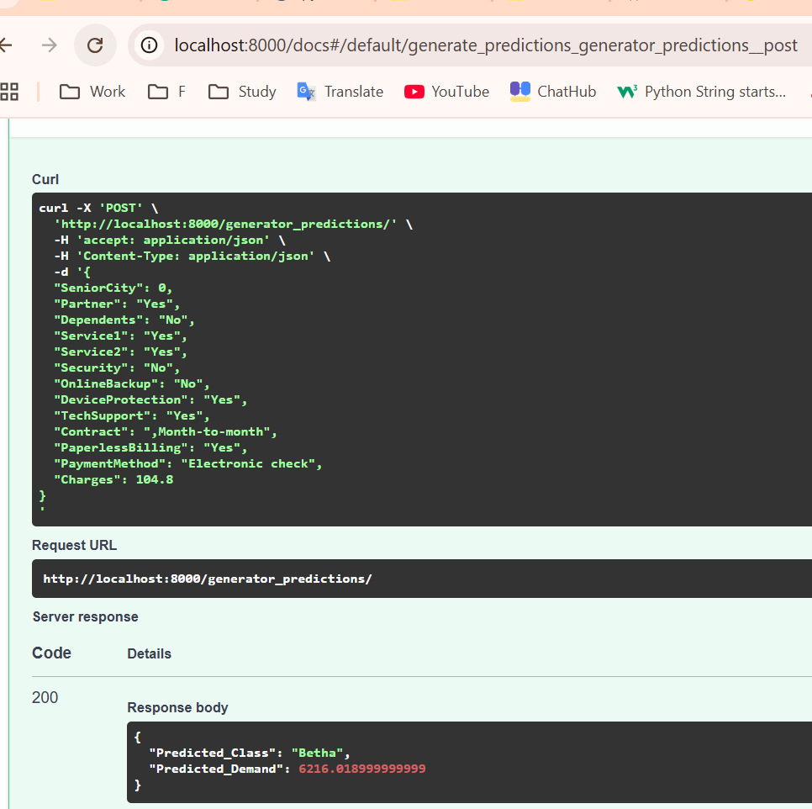

8168-UQWWF,0,No,No,Yes,Yes,No,No,Yes,No,Month-to-month,Yes,Bank transfer (automatic),97.85,1105.4,Betha

